Project: Electric Appliance Management System
AppliTrack
Contents:

SL No | Index | Page No
1 | Abstract | 2
2 | Introduction | 3
3 | Problem Statement | 3
4 | Aim of the Project | 4
5 | Objectives | 4
6 | Scope of the Project | 5
7 | System Design | 6
8 | Methodology / Technologies Used | 7
9 | Conclusion | 8

Project: Electric Appliance Management System
AppliTrack

Abstract:
AppliTrack – Electric Appliance Management System is a smart and centralized platform designed to efficiently manage and monitor electrical appliances in homes, offices, and industries. The system allows users to register appliances, record usage patterns, and maintain essential details such as warranty, service history, and maintenance schedules. It provides timely alerts and notifications for repairs, replacements, and service reminders, ensuring minimal downtime and extended appliance lifespan. An integrated admin dashboard facilitates centralized monitoring of multiple devices, inventory control, and energy optimization. By streamlining appliance tracking and maintenance, AppliTrack enhances operational efficiency, reduces costs, and promotes sustainable energy usage.

Project: Electric Appliance Management System
AppliTrack
Introduction:
In today’s technology-driven world, electric appliances play a vital role in homes, offices, and industries. From basic household devices to advanced industrial machines, their efficient management is crucial for ensuring smooth operations and reducing unexpected failures. However, manual tracking of appliances, service schedules, and warranty details often leads to inefficiency, missed maintenance, and unnecessary expenses.
AppliTrack – Electric Appliance Management System provides a centralized solution to address these challenges. It enables users to register appliances, monitor their usage, and keep track of service history and warranty details. With automated alerts and reminders, the system ensures timely maintenance and replacements. Furthermore, the admin dashboard offers insights into energy consumption, inventory status, and overall appliance performance, promoting cost efficiency and sustainable energy usage.

Problem Statement:
Managing multiple electrical appliances manually is time-consuming, prone to errors, and inefficient. Users often forget maintenance schedules, lose warranty records, or fail to detect energy overuse, which results in increased downtime, higher costs, and reduced appliance lifespan. In industries and offices, the absence of a centralized monitoring system leads to poor resource utilization, lack of accountability, and difficulty in handling bulk inventory.

Aim of the Project:
The main aim of StaffSphere – Employee Management System (EmpTrack) is to design and develop a centralized web-based platform that automates and streamlines employee-related processes such as personal data management, attendance, payroll, task allocation, and performance monitoring. The system seeks to enhance organizational efficiency, ensure data security, and improve workforce productivity through effective HR management.

Objectives:
Based on the project's aim, the key objectives are to:
- Centralized Appliance Management – To provide a single platform for registering and tracking all electrical appliances in homes, offices, or industries.
- Automated Maintenance Reminders – To send alerts for service schedules, warranty expiry, repairs, and replacements.
- Energy Optimization – To monitor appliance usage patterns and suggest measures for reducing energy consumption.
- Inventory Management – To help administrators manage multiple appliances efficiently, including purchase, stock, and replacement details.
- Improved Decision-Making – To generate reports and insights that assist in reducing downtime and extending the appliance lifespan.
- User-Friendly Access – To ensure an intuitive interface for both individual users and administrators for easy appliance tracking.

Scope of the Project:
- The system can be used in households for managing appliances like refrigerators, washing machines, air conditioners, etc.
- In offices, it can track electronic devices such as computers, projectors, servers, and communication systems.
- In industries, it can handle large-scale machines, electrical equipment, and backup systems.
- It supports multi-user access where both users and administrators can manage appliances.
- The platform ensures efficient monitoring by storing usage history, warranty, and service records.
- Future scope includes integrating IoT-enabled smart sensors for real-time energy tracking and predictive maintenance.

System Design:

1. Architecture Layers
- Presentation Layer (Frontend)
  - Provides a user-friendly interface for users and admins.
  - Features: Appliance registration, usage tracking, alerts & notifications, dashboards.
  - Technology (example): HTML, CSS, JavaScript, React.js/Angular.
- Application Layer (Backend)
  - Handles business logic, appliance management, and alert generation.
  - Manages user authentication, appliance records, maintenance scheduling, and reports.
  - Technology (example): Node.js / Java / Python (Django/Flask).
- Database Layer (Storage)
  - Stores appliance details (ID, type, usage logs, warranty, service history).
  - Maintains user accounts, inventory, and alert records.
  - Technology (example): MySQL / PostgreSQL / MongoDB.

2. System Modules
- User Module
  - Register/login and manage personal appliances.
  - View usage history, warranty status, and receive alerts.
- Admin Module
  - Manage multiple appliances across homes, offices, or industries.
  - Monitor energy usage and generate reports.
  - Control inventory and oversee maintenance.
- Appliance Management Module
  - Register new appliances with details (model, serial number, purchase date, warranty).
  - Track usage and service history.
- Alert & Notification Module
  - Sends reminders for maintenance, warranty expiry, and repairs via email/SMS/app.

ER Diagram:

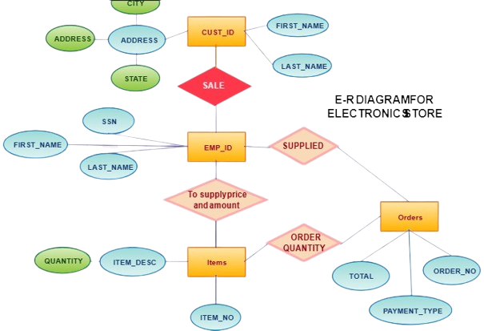

Hardware Requirements
- Processor: Intel Core i3 or higher
- RAM: 4 GB (8 GB recommended)
- Storage: 250 GB HDD / SSD (SSD preferred)
- Display: Minimum 1366×768 resolution
- Network: Stable internet connection (10 Mbps or higher)
- Webcam & Microphone: For online proctoring
- Operating System: Windows 10

Software Requirements
Frontend:
- React.js – UI development
- Axios – API calls and data fetching
- Tailwind CSS – Styling and responsive design

Backend:
- Node.js – Server-side runtime
- Express.js – API and routing
- Next.js – Server-side rendering and routing optimization

Database:
- SQL (MySQL / PostgreSQL) – Data storage

Other Tools:
- Git & GitHub – Version control
- Postman – API testing
- VS Code – Code editor

Conclusion
AppliTrack provides an effective and centralized solution for managing electric appliances across homes, offices, and industries. By automating appliance registration, service reminders, warranty tracking, and energy usage monitoring, the system reduces downtime, lowers maintenance costs, and extends the lifespan of equipment. The admin dashboard ensures efficient inventory management and offers actionable insights through detailed reports and analytics. With its user-friendly interface and scalable design, AppliTrack not only simplifies appliance management but also contributes to energy conservation and sustainable practices. In the future, integrating IoT-based sensors and predictive analytics can further enhance its capability, making it a complete smart appliance management solution.

Thank you…

